Assignment 05:
Note: To solve below queries, use “hr” database
1. Display all the first names in lower case and the last names in upper case as the single column separated with ' - '. Provide the meaningful name to the column.
SELECT CONCAT(LOWER(first_name), ‘-‘, UPPER(last_name)) AS ‘full_name’ FROM employees;

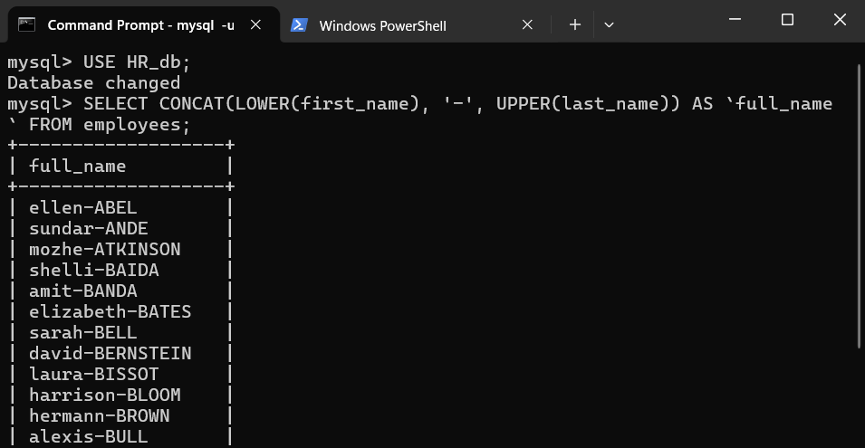

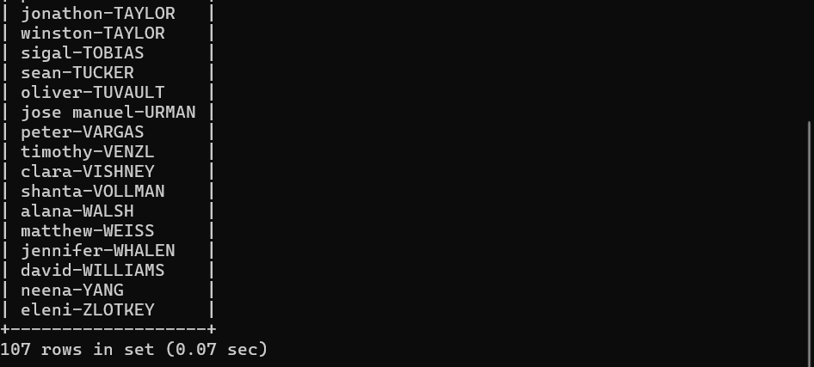
2. Display the first word of the job title. (Hint : Use substring_index).
SELECT SUBSTRING_INDEX(`job_title`, ‘ ’, 1) AS `first_word` FROM jobs;
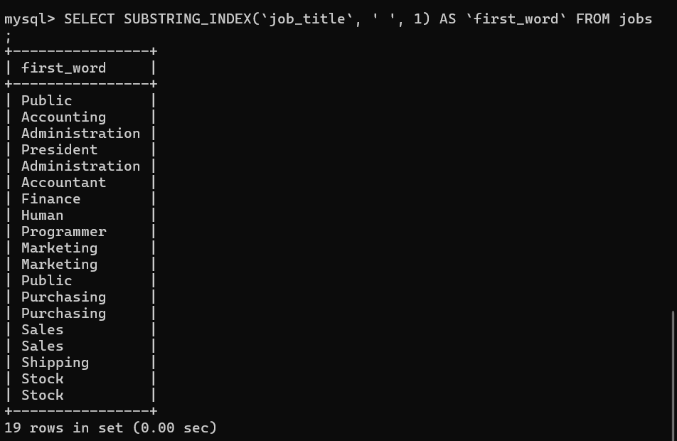

3. Display the First name, last name and length of first name for the employees whose last name contains character ‘b’ anywhere after 3rd position.
SELECT `first_name`, LENGTH(first_name) AS `length(first_name)`,
`last_name`
FROM employees
WHERE `last_name` LIKE ‘___%b%’;

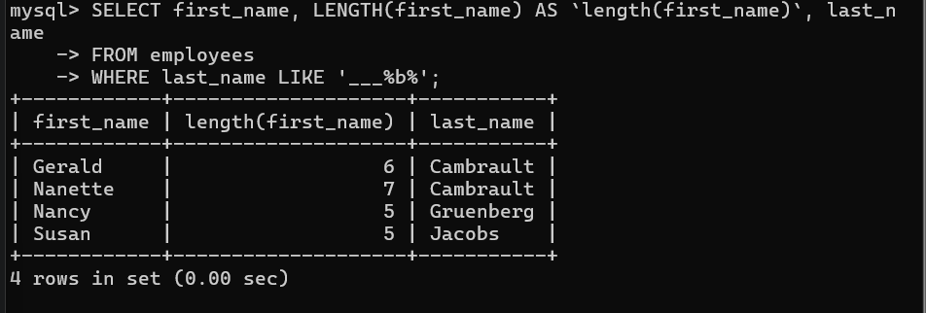

4. Display the employee id, first name and last name of the employees whose first or last name includes a space in between.
SELECT employee_id, first_name, last_name
FROM employees
WHERE first_name LIKE ‘% %’ OR last_name LIKE ‘% %’;

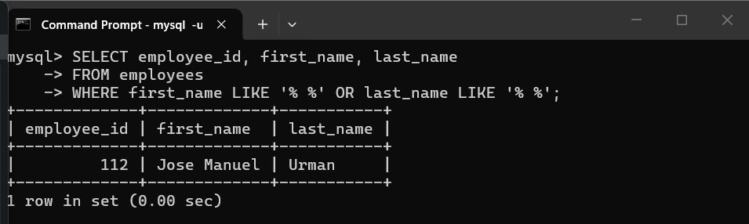
5. Display first name, salary, and round the salary to thousands.

SELECT first_name, salary, ROUND(salary, -3)
FROM employees;
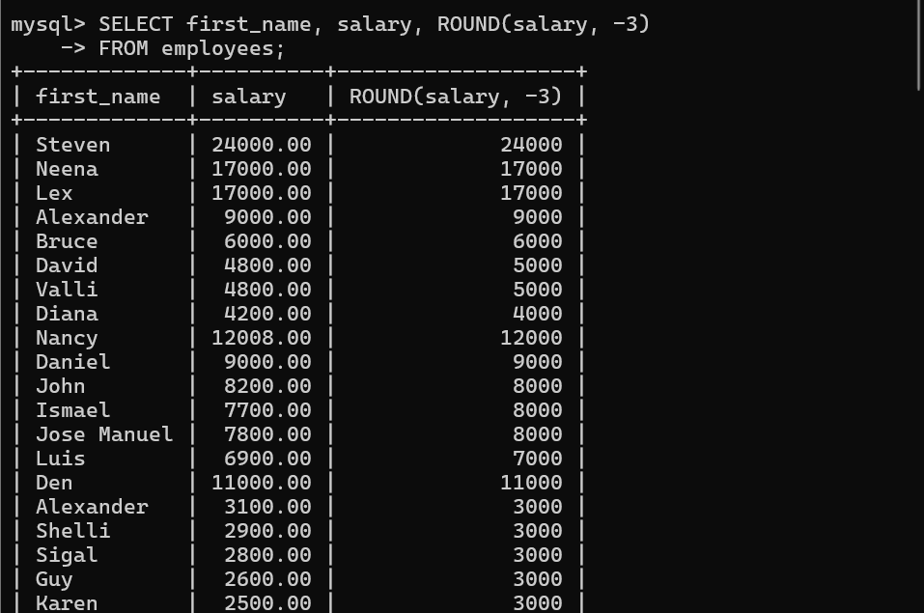

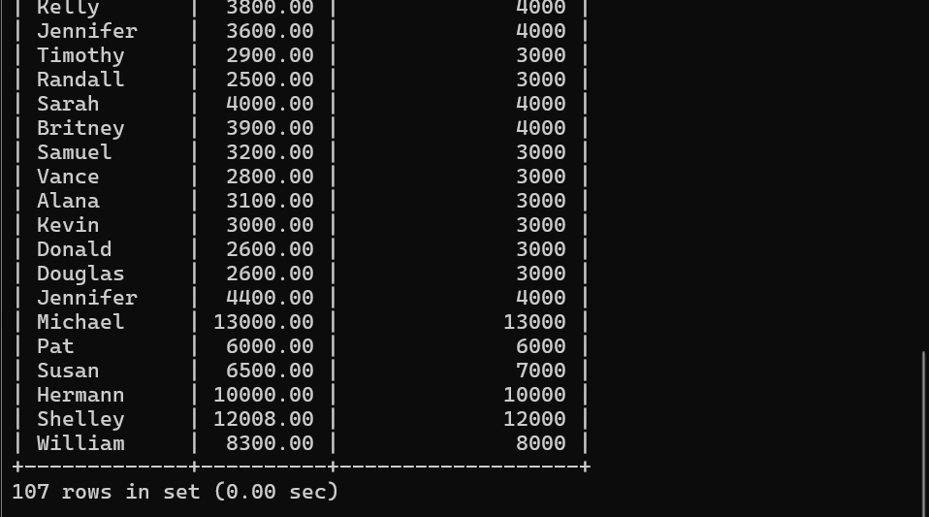

6. Display employee ID and the date on which he ended his previous job in the format as mentioned. (Format: Thursday, October 27th 2011)

SELECT employee_id, end_date,
DATE_FORMAT(end_date, ‘%W, %M %D %Y’) AS ‘Job_end_date’
FROM job_history;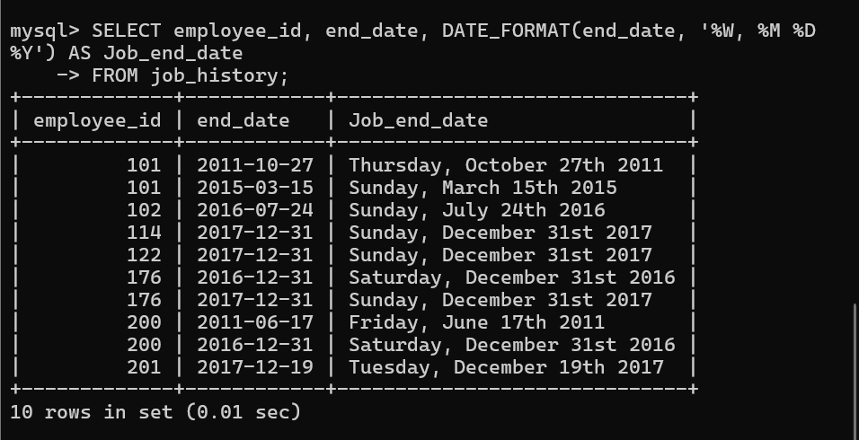

7. Display first name and date of first salary of the employees. (Consider 1st day of month as salary day. HINT: LAST_DAY).

SELECT employee_id, first_name, hire_date,
LAST_DAY(hire_date) + INTERVAL 1 DAY AS first_sal
FROM employees;
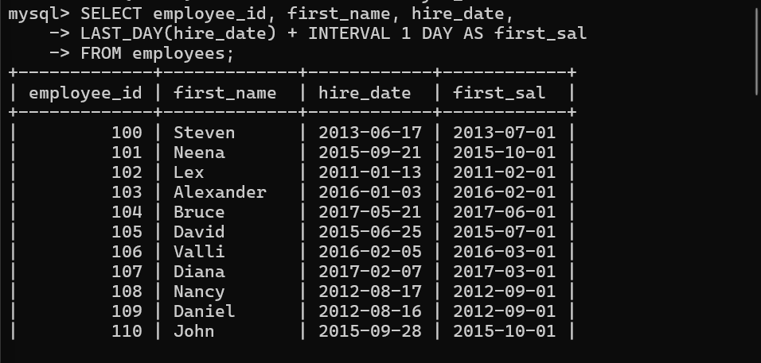

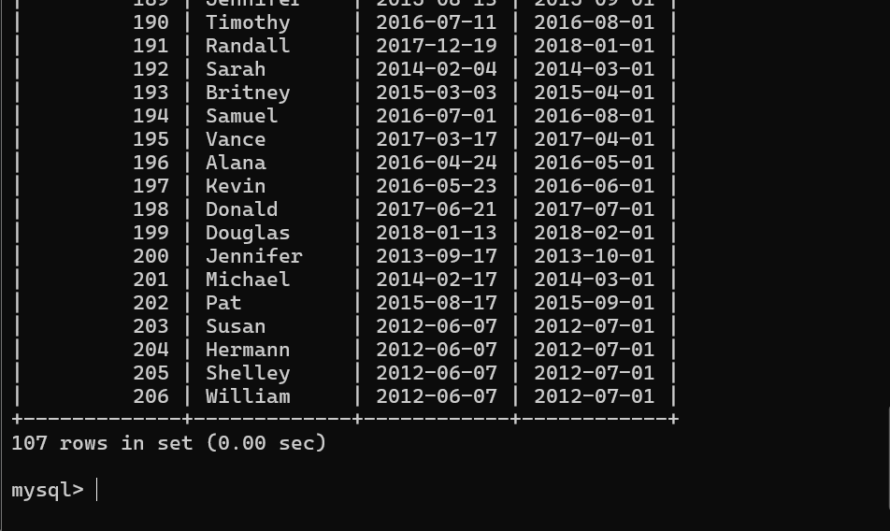

8. Display first name and experience of the employees in the format of number of years, months and days completed

SELECT first_name, hire_date,
CONCAT(
TIMESTAMPDIFF(YEAR, hire_date, CURDATE()), ‘ Years, ‘,
TIMESTAMPDIFF(MONTH, hire_date, CURDATE()) % 12, ‘ Months, ’,
DATEDIFF(
CURDATE(),
hire_date + INTERVAL TIMESTMPDIFF(MONTH, hire_date, CURDATE()) MONTH
), ‘ Days’
) AS ‘experience’
FROM employees;
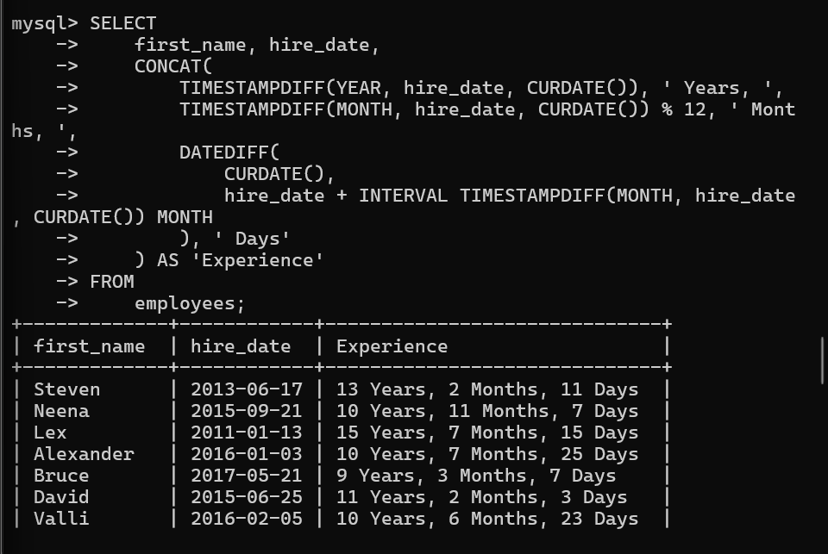
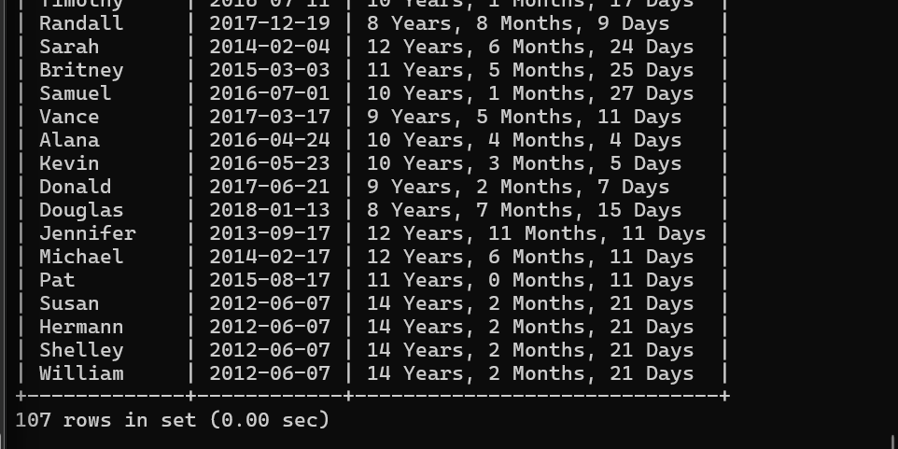

9. Display the employee id, first name and joining date of the employees who joined in the month of august of any year.

SELECT employee_id, first_name, hire_date
FROM employees
WHERE MONTH(hire_date) = 8;
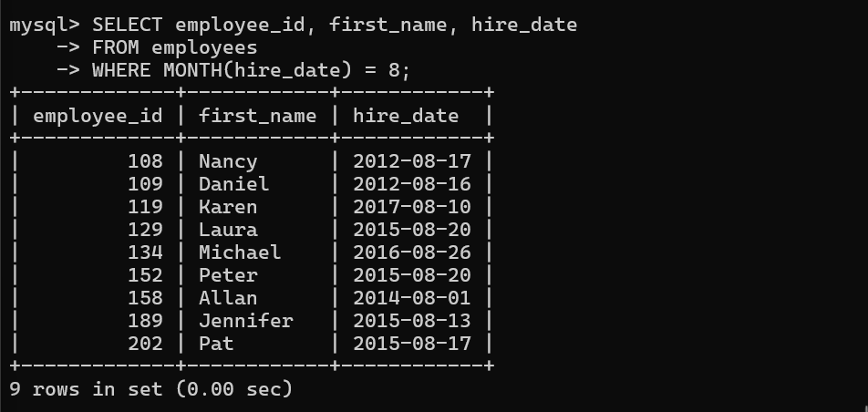
10. Display the details of employees who joined before the year 2015.

SELECT employee_id, hire_date
FROM employees
WHERE hire_date < ‘2015-01-01’;

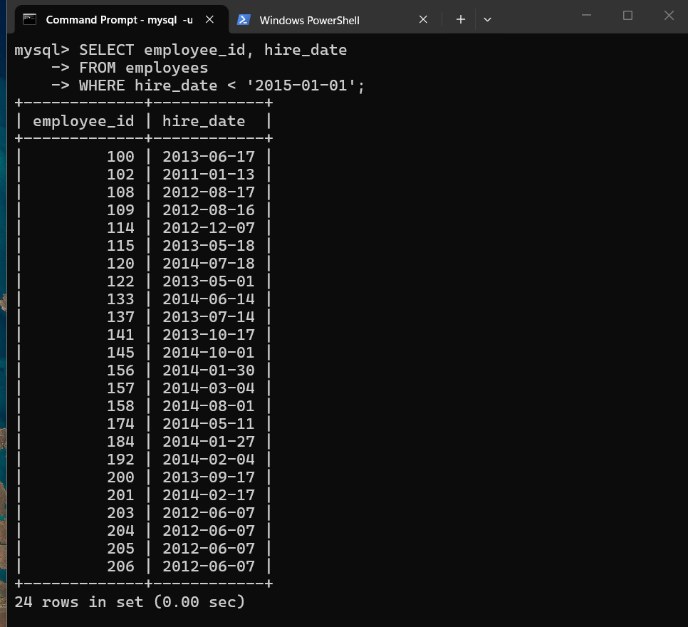

11. Display the number of days between system date and 1st January 2011.

SELECT DATEDIFF(CURDATE(), ‘2011-01-01’) AS ‘difference’;
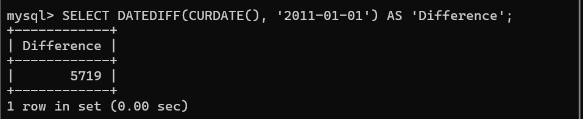

12. Display number of employees joined after 15th of any month.

SELECT COUNT(employee_id) AS count
FROM employees
WHERE DAY(hire_date) > 15;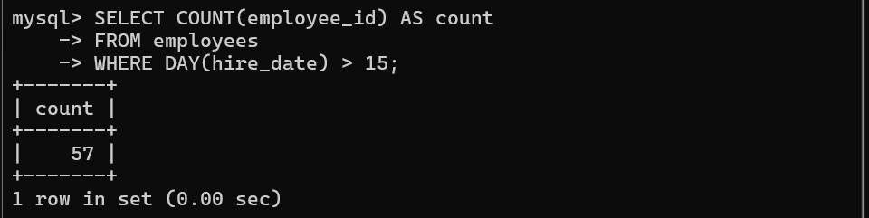

13. Display third highest salary of employees.

SELECT salary FROM employees
ORDER BY salary DESC
LIMIT 3,1;

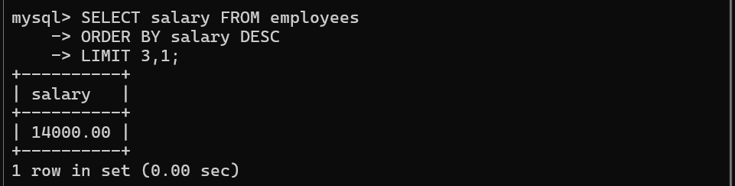

Note: To solve below queries, use “spj” database

- Display all the Suppliers, belonging to cities starting with the letter
‘L’.

SELECT * FROM S
WHERE city LIKE ‘L%’;
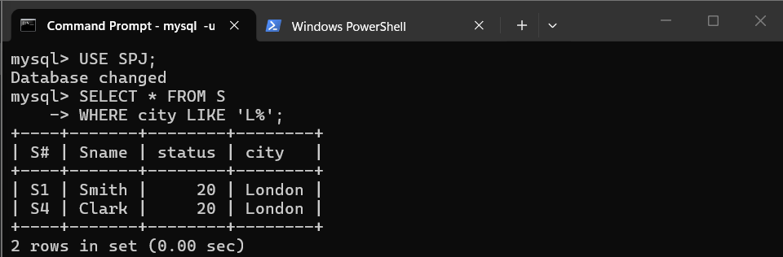

- Display all the Jobs, with the third letter in JNAME as ‘n’.

SELECT * FROM J
WHERE jname LIKE ‘__n%’;
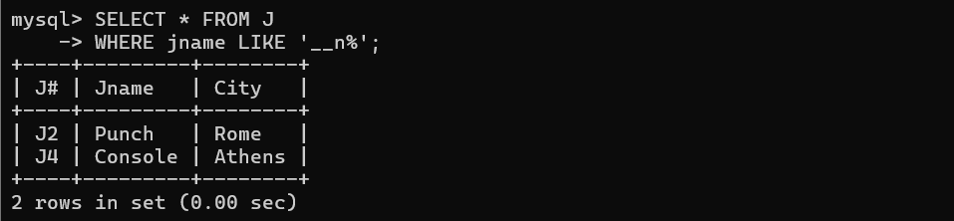

- Display all the Supplier names with the initial letter capital.

SELECT sname AS names
FROM S
WHERE sname REGEXP ‘^[A-Z]+’;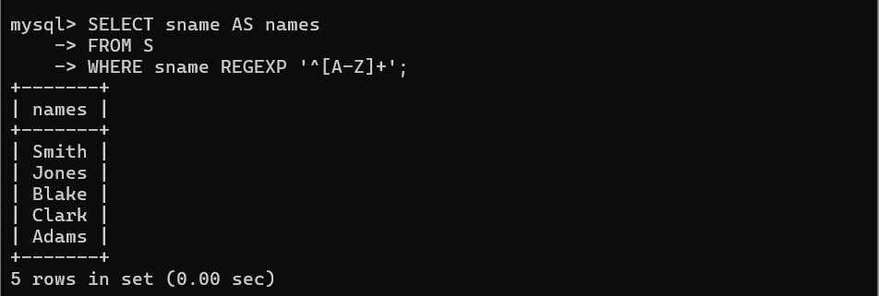

- Display all the Supplier names in upper case.

SELECT UPPER(sname) FROM S;
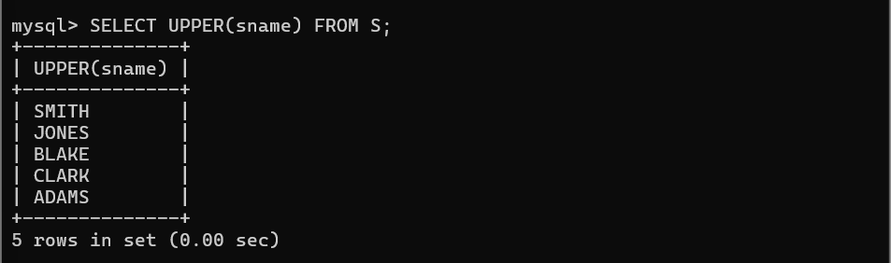

- Display all the Supplier names in lower case.

SELECT LOWER(sname) FROM S;
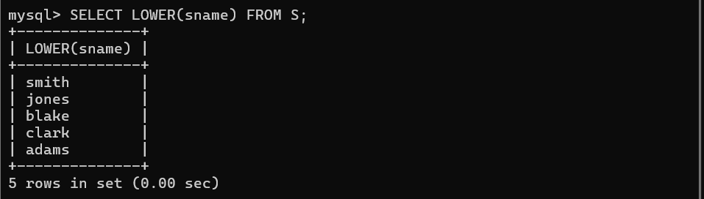

- Display the Supplier names and the lengths of the names.

SELECT Sname, LENGTH(Sname) AS ‘length_of_names’
FROM S;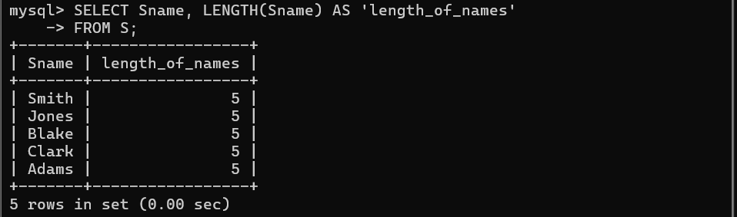

- Display the current day (e.g. Thursday).

SELECT DAYNAME(NOW());
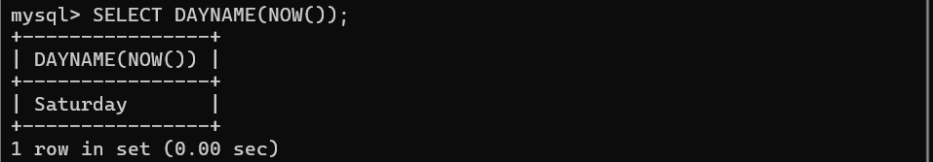

- Display the minimum Status in the Supplier table.

SELECT MIN(status) FROM S;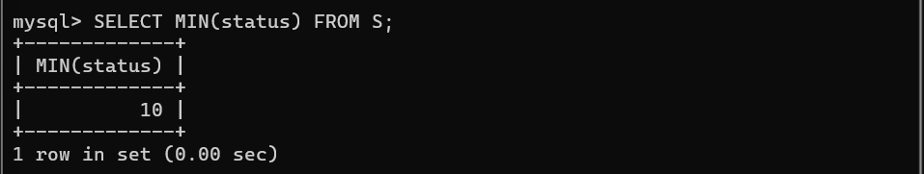

- Display the maximum Weight in the Parts table.

SELECT MAX(weight) FROM P;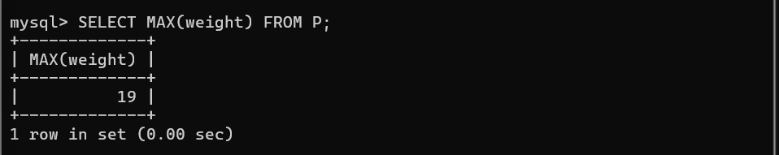

- Display the average Weight of the Parts.

SELECT AVG(weight) FROM P;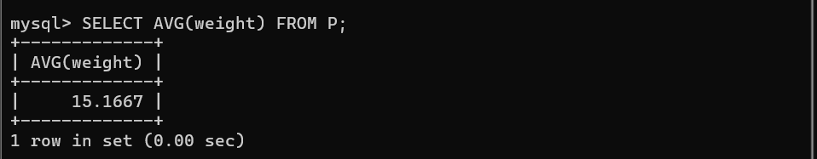

- Display the total Quantity sold for part ‘P1’.

SELECT SUM(QTY) FROM SP WHERE `P#` = ‘P1’;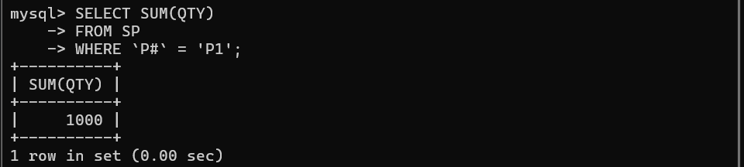

- Display all the Supplier names (with ‘la’ replaced by ‘ro’). HINT: REPLACE
SELECT sname, REPLACE(sname, ‘la’, ‘ro’) AS ‘new_name’ FROM S;

